**Illustrative Application of *Drekkaṇa Swarōpās* in Cowry *Praśnās*.**

**Muralidharan K.**

**M. A. (Astrology), PhD Scholar**

***Muralidharan K is a retired Tehsildar who holds a Master’s degree in Astrology and Research scholar and practicing astrologer from Thiruvananthapuram, Kerala . Being a post graduate from Potti Sriramlu University, Hyderabad, he continued his venture in practicing Astrology to a point where he opted astrology to be his way forward. An experience of twenty years’ tireless hard work enabled him to become a proficient deivajna. He is in the process of submitting his PhD from JKR Astro Research Foundation, Hyderabad in the field of devaprashna and drekkaṇa swarōpās***

Of the twelve *rāśis* in the zodiac, each sector divides itself into three subsectors known as *drekkaṇa.* Each of these *drekkaṇas* are further attributed with there own unique and significant *drekkaṇa swarōpās*, which, when applied in various *praśnās* unveil the hidden aspects from which the matter can be analysed. A precise and meticulous comprehension of these *drekkaṇa swarōpās* have been enunciated by Varāhamihira Āchāryā in his treatise *Brihat Jātaka* which became one among the five major treaties on Hindu predictive astrology. Being accepted as India’s foremost astrological text, the study of *Brihat Jātaka* makes one grasp the fundamentals of astrology. A detailed illustration using the first *drekkaṇa swarōpa* of the zodiac sign Leo and its practical application in the *praśna* forms the base of this article.

The first *drekkaṇa swarōpa* of Leo, as per the *ślōka*:

*Śālmalerupari ɡridhra jambukau*

*Śwā naraścha malināmbarānvitha;*

*Routi māthrupithru viprayōjith*

*Simha* *rōpamidamādyamuchyathe*.

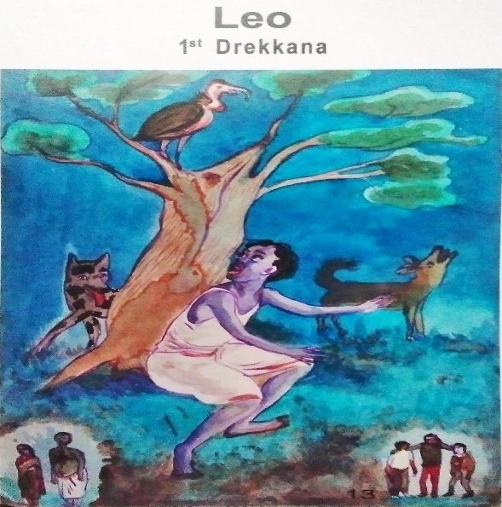

Portrays a distressed and exhausted raggedy man in shabby cloths who reminisces his nostalgic past concerning home, parents and friends. He is surrounded by blood-thirsty animals (a vulture and a fox), in the midst of a forest, with no powerful allies to aid. The only assistance that is accessible to this worn-out man is the service of a passive and fragile companion who is represented in the form of a dog. The depicted crooked fox has an eye for the destruction of the man and is prepared with his devious measures. The vulture sitting in the tree branch just above the man observes the whole drama just to satiate his needs by feeding on the dead corpse. Both their eyes are on the man’s downfall so as to benefit out of it.

The very sight of the man, his horrified look, his attires and attributes and the nature of the depicted animals resort to the wholesome expression of the *drekkaṇa swarōpa.* Whereas, the associated *dharma* can also be deciphered out from these *swarōpās*. Such a decoding of various *drekkaṇa swarōpās* based on the twin clauses: expression and *dharma*, assist the practitioner to apply the same to the *praśnās* that call for his service.

On the light of this, let me demonstrate how to analyse a cowry *praśna* which came to my attention lately. A person approached me on 24/7/2022 at 12:15pm at Trivandrum. The *ārōda* of cowry *praśna* falls on the first *drekkaṇa* of Leo. The concomitant *praśna* chart that came up has also been provided below.

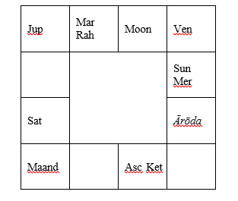

The man was concerned about his children’s health as they were frequently struck by diseases and were constantly hospitalised. The financial status of the man was also not quite stable as he is unfortunate in thriving to meet his family’s expenses. The death of his wife further distressed his situation. As we could see, all these matters resonate with the appearance and the pitiful state of the raggedy man in the first *drekkaṇa* of Leo. The only assistance for this man came from his friends who were little better than he himself. This is where the portrayal of the passive dog and its *dharma* came into play. He believed that his situation had been badly influenced and manipulated by his enemies who resorted to black magic in order to shatter his peace of mind. Here, they act as both deceitful fox and flesh-eating vulture since they were knitting a wrongful plan not just to defeat the worn-out man but to crush him along with his grief. Thus, the twin clauses of the *drekkaṇa swarōpa* mentioned afore (expression and *dharma*) go well with the *praśna* or the circumstances of the man.

It is to be noted that all the thirty-six *drekkaṇa swarōpās* of the twelve zodiac signs resonate the same way as mentioned above. Much focus be given to deriving apt meaning out of the *drekkaṇa swarōpās* and connecting it with the situation at hand.